Part A
Q1)
Level-1 Model (individual growth across time points-level)
MATH_{tij} = π_{0ij} + π_{1ij}*(YEAR_{tij}) + π_{2ij}*(YEARSQ_{tij}) + e_{tij}
Where:
MATH_{tij} : the expected outcome for the variable of math achievement at the time t for child i and school j.
π_{0ij} : the initial status of child i in school j or the expected outcome for child i in the spring of first grade in school j.
π_{1ij}*(YEAR_{tij}): is the instantaneous growth rate at the time of spring of 1st grade for child i for school j.
π_{2ij}*(YEARSQ_{tij}): This is the curvature term that captures the acceleration in each growth rate trajectory at time t for child i and school j. It represents the non-linear or quadratic change in growth trajectory in the model.
e_{tij} : is a level-1 random effect that represents the deviation of growth trajectories across different time points from the predicted score based on the level-1 model. Assumed normally distributed, with a mean of 0 and a variance.
Level-2 Model
π_{0ij} = β_{00j} + β_{01j}*(BLACK_{ij}) + β_{02j}*(HISPANIC_{ij}) + r_{0ij}
π_{1ij} = β_{10j} + β_{11j}*(BLACK_{ij}) + β_{12j}*(HISPANIC_{ij}) + r_{1ij}
π_{2ij} = β_{20j} + β_{21j}*(BLACK_{ij}) + β_{22j}*(HISPANIC_{ij}) + r_{2ij}
where:
π_{0ij} / π_{1ij} / π_{2ij} : level-1 terms’ slopes as outcomes being predicted by level-2 coefficients
β_{00j} : the mean math achievement in school j for white students / the intercept for school j.
β_{01j}*(BLACK_{ij}): the estimated difference in the slopes of math scores between black students and white students, holding other variables constant.
β_{02j}*(HISPANIC_{ij}): the estimated difference in the slopes of math scores between hispanic students and white students, holding other variables constant.
r_{0ij} : this is level 2 random effect that represents the deviation of individual i at school j’s math achievement from its predicted value based on the time points-level model.
β_{10j} : the instantaneous growth rate of math achievement at the time of the spring of 1st grade for white individuals in school j.
β_{11j}*(BLACK_{ij}): the estimated difference in the instantaneous growth rate of math scores between black and white individuals in school j, holding other variables constant.
β_{12j}*(HISPANIC_{ij}): the estimated difference in the instantaneous growth rate of math scores between Hispanic and white individuals in school j, holding other variables constant.
r_{1ij} : this is the level 2-random effect that represents the deviation of individual in school j’s level one coefficient from its predicted value based on the individual-level model.
β_{20j} : the intercept for for school j in modeling the classroom effect of the curvature term, for white students.
β_{21j}*(BLACK_{ij}): the estimated difference in the growth rate or acceleration between black and white individuals in school j, holding constant other variables.
β_{22j}*(HISPANIC_{ij}): the estimated difference in the growth rate or acceleration between Hispanic and white individuals in school j, holding constant other variables.
r_{2ij} : this is level 2 random effect that represents the deviation of individual i at school j’s level one coefficient, the curvature term, from its predicted value based on the time individual-level model.
Level-3 Model
β_{00j} = γ₀₀₀ + u_{00j}
β_{01j} = γ₀₁₀
β_{02j} = γ₀₂₀
β_{10j} = γ₁₀₀ + u_{10j}
β_{11j} = γ₁₁₀
β_{12j} = γ₁₂₀
β_{20j} = γ₂₀₀ + u_{20j}
β_{21j} = γ₂₁₀
β_{22j} = γ₂₂₀
All the Betas: level-2 terms’ slopes as outcomes being predicted by level-3 coefficients
γ₀₀₀ : the mean of school means or the grand mean for white students.
u_{00j} : the random school effect or the deviation of school j’s mean of math achievement from the grand mean.
γ₀₁₀ : the mean difference in math achievement slopes between black and white students.
γ₀₂₀ : the mean difference in math achievement slopes between Hispanic and white students.
γ₁₀₀ : the average increase in the math achievement with each 1 year increase in age.
u_{10j} : the random effect for the year slopes
γ₁₁₀ : the instantaneous growth rate for the estimated difference between the black students and white students.
γ₁₂₀ : the instantaneous growth rate for the estimated difference between the Hispanic students and white students.
γ₂₀₀ : the curvature term for the growth rate trajectories.
u_{20j} : the random effect for the curvature term.
γ₂₁₀ : the expected difference in the curvature growth rate trajectories between black and white students.
γ₂₂₀ : the expected difference in the curvature growth rate trajectories between Hispanic and white students.
Q2)
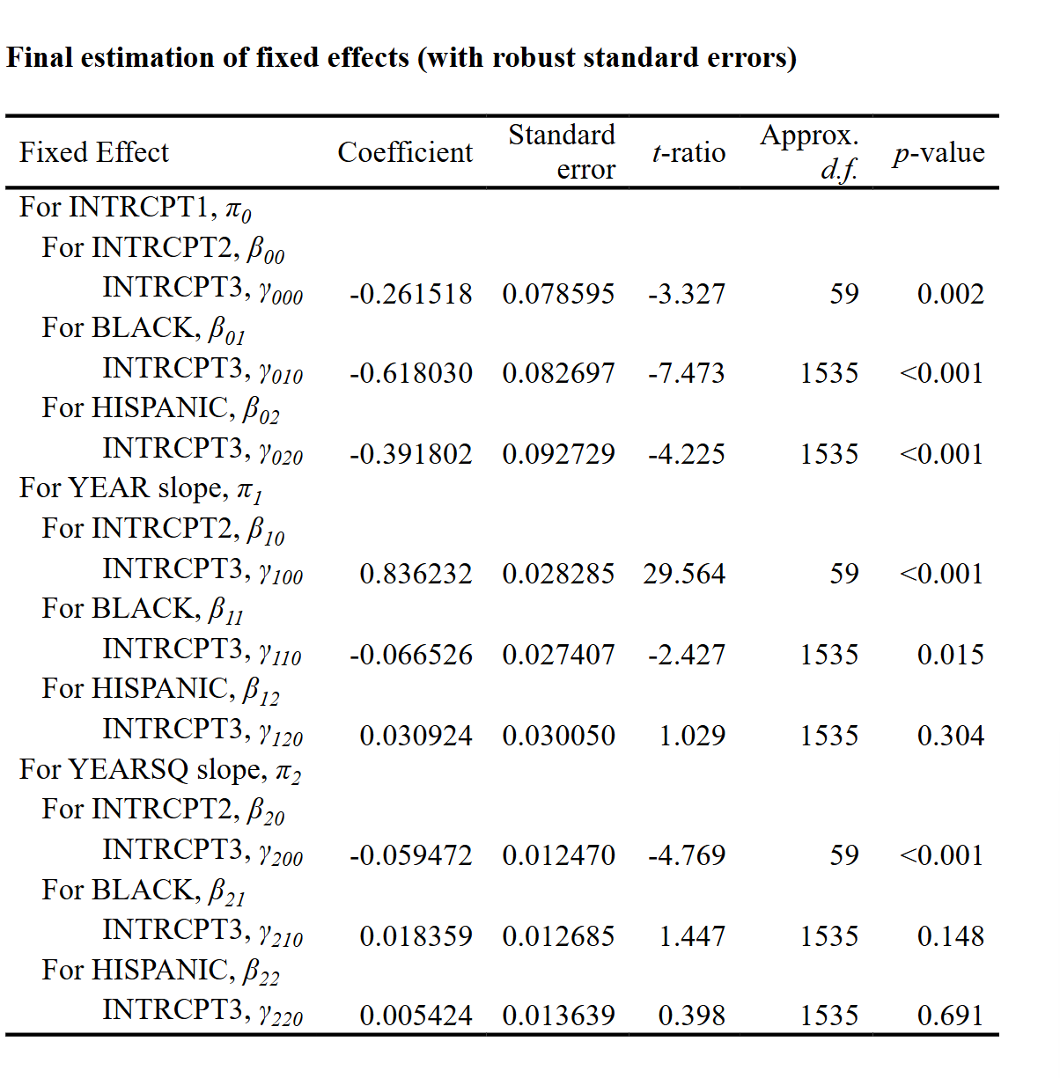
According to the output, we are presented with a γ₀₀₀, which equals to -0.261518. this means that for the reference group, the white students who are at the spring of their 1st grade, the expected intercept equals to 0.262 points lower than zero where the p-value is small, thus there is difference in the intercept. The γ₀₁₀ refers to the expected intercept for the black individuals which is equal to 0.618030 units below zero and lower than white students. The p-value is small and thus there is strong statistical evidence that the intercept for black students differs from zero. the γ₀₁₀ refers to the expected intercept for Hispanic students which is equal to 0.391802 units lower than zero and also lower than white students. The p-value is the same as the case of the black student.
The γ₁₀₀ here represents the instantaneous growth rate which equals to 0.836232 units increase in math achievement for the reference group. The small p-value compels us to believe that there is strong evidence for statistical significance and that there is a difference of the value from zero. the γ₁₁₀ here is the difference in the year slope for black students relative to the baseline group or the white students. Black students are expected to have an increase in their mathematical achievement of 0.066526 points lower than their white counterpart, holding everything constant. Similarly, the γ₁₂₀ refers to the difference in the year slope for Hispanic students relative to white students, while holding all other variables constant. The Hispanic students are expected to achieve higher mathematical achievement than white students by a magnitude of 0.030924 points. However, we notice that the p-value is significant for the black students, while it is not with the Hispanic students. We infer that there is a gap between black and white students, while we don’t have enough statistical evidence to prove that there is difference between Hispanic and white students.
The γ₂₀₀ value of -0.059472 represents the intercept for the curvature of the growth rate for white students. Here we note that there is a negative quadratic effect of the effect of Year, this indicates that there is deceleration in the outcome over time. the small p-value tells us that there is indeed strong evidence to say that curvature is strong enough. The γ₂₁₀ is the difference in the quadratic term between the black and white students, while holding all other variables constant. The value equals to 0.018359, by adding it to the intercept quadratic term, we notice that the curvature bends slightly less for black students. However, the large p-value suggests we do not have enough evidence to support such claim, thus the difference is indistinguishable from zero. finally, the γ₂₂₀ represents the difference in the curvature between the Hispanic and white students. Here it shows that the trajectory for Hispanic students are expected to bend slightly less. Again, the p-value is small which means we don’t have enough evidence to back such claim.

Q3)
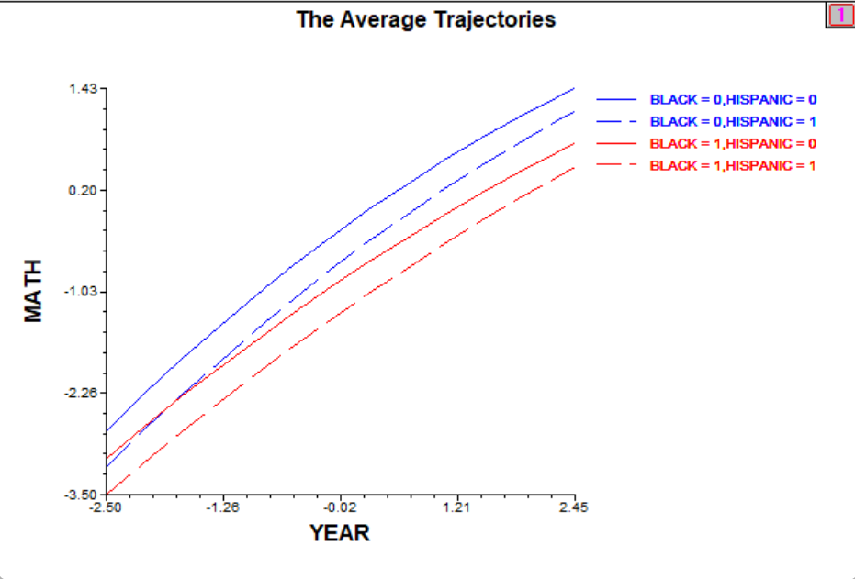
According to the graph, we note that all the slopes have an increase in achievement with a decreasing rate, which explains the negative curvature coefficient for the white students specifically, and the slightly lower negative effect for the Hispanic and black students. We also note that the white students are taking the lead in the trajectory, this shows an initial gap in growth between the different races.
Q4)
Since we allowed only three terms to vary in the level-3 model, namely the intercept for the baseline and the first two variables, we have assumptions for this. First, by checking the variance components and their p-values, we notice that there are statistical strong evidences that they vary, which means we are testing to see whether we have a case of homogeneity, and we appear to be having a case of heterogeneity. Second, we may do this to nested data to ensure no underestimation for the for the standard errors, which prevents type 1 errors. Finally, we might be trying to do a hypothesis testing to see if the variances do vary and if they are worth adding to the model since their effect size might be important.

Q5)
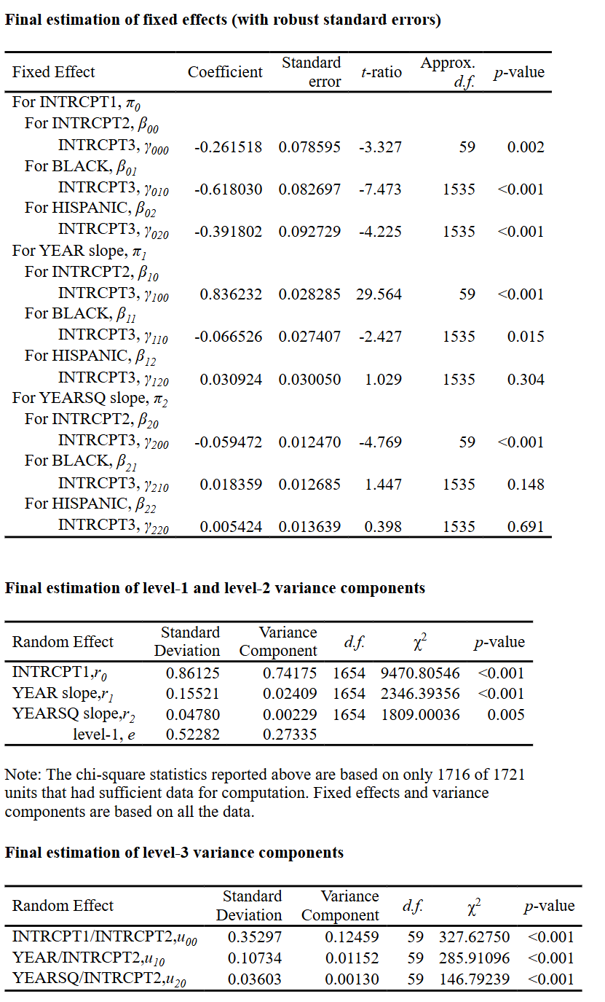
- plausible value intervals for the child-level variation in achievement for white students:
- -0.261518±1.96*(0.86125) = (-1.949568 , 1.426532)
- Under normality assumption, we would expect 95% of the child-level means of achievement for the white students to fall within this range. Moreover, this range indicates a relatively small range in average achievement of the white students in the child-level
- the school-level variation in achievement for white students.
- -0.261518±1.96*(0.35297) = (-0.9533392 , 0.4303032)
- Under the normality assumption, we expect 95% of the school-level means of math achievement for white students to fall in this interval.
Q6)
Revised model and output:
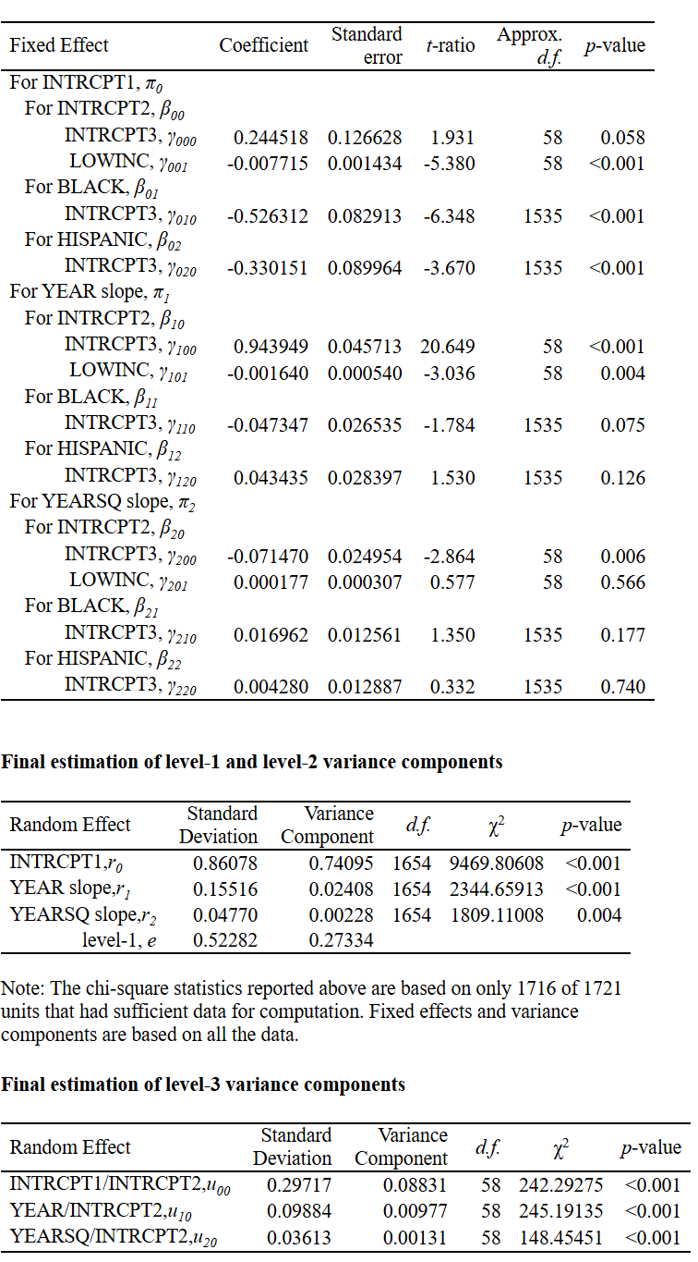
Level-1 Model
MATH_{tij} = π_{0ij} + π_{1ij}*(YEAR_{tij})+ π_{2ij}*(YEARSQ_{tij})+ e_{tij}
Level-2 Model
π_{0ij} = β_{00j} + β_{01j}*(BLACK_{ij})+ β_{02j}*(HISPANIC_{ij})+ r_{0ij}
π_{1ij} = β_{10j} + β_{11j}*(BLACK_{ij})+ β_{12j}*(HISPANIC_{ij})+ r_{1ij}
π_{2ij} = β_{20j} + β_{21j}*(BLACK_{ij})+ β_{22j}*(HISPANIC_{ij})+ r_{2ij}
Level-3 Model
β_{00j} = γ₀₀₀ + γ₀₀₁(LOWINC_{j})+ u_{00j}
β_{01j} = γ₀₁₀
β_{02j} = γ₀₂₀
β_{10j} = γ₁₀₀ + γ₁₀₁(LOWINC_{j})+ u_{10j}
β_{11j} = γ₁₁₀
β_{12j} = γ₁₂₀
β_{20j} = γ₂₀₀ + γ₂₀₁(LOWINC_{j})+ u_{20j}
β_{21j} = γ₂₁₀
β_{22j} = γ₂₂₀
According to our output, we find that γ₁₀₁ equals to -0.001640, which means that schools with low income students concentration are expected to have lower growth rates, has a small p-value that suggests that there is association between having low income and the decrease in growth rates. Moreover, the curvature term, γ₂₀₁, shows a positive value of 0,000177, which means students with low income are exhibiting a decreasing growth rate over time. however, the p-value for the curvature term of the growth rates for the low-income students is not significant, thus we have no enough evidence to back such claim for the rate of change.

Q7)
In comparison between the first and the second model, we find that the instantaneous growth rate for the student at the spring of 1st grade changed from 0.0836232 in the first model to 0.943949 in the second model after controlling for the poverty concentration. As for the curvature terms, in the first model, it was -0.059472, which means increasing with a decreasing rate. In the new model, the curvature term, while controlling for the poverty concentration, has become -0.071470. this means that there was an increase in the growth rate with a decreasing rate, and now the decreasing rate slightly increased in negative terms. Moreover, the growth rate slightly increased after controlling for the concentration of poverty. Overall, this indicates that poverty concentration variable is a significant omitted variable. We can note that after controlling for the variable, the initial rate of change is actually steeper than the original model suggested. As for the more negative acceleration, this means that the trajectory is decelerating more sharply over time.

Part 2
Q1)
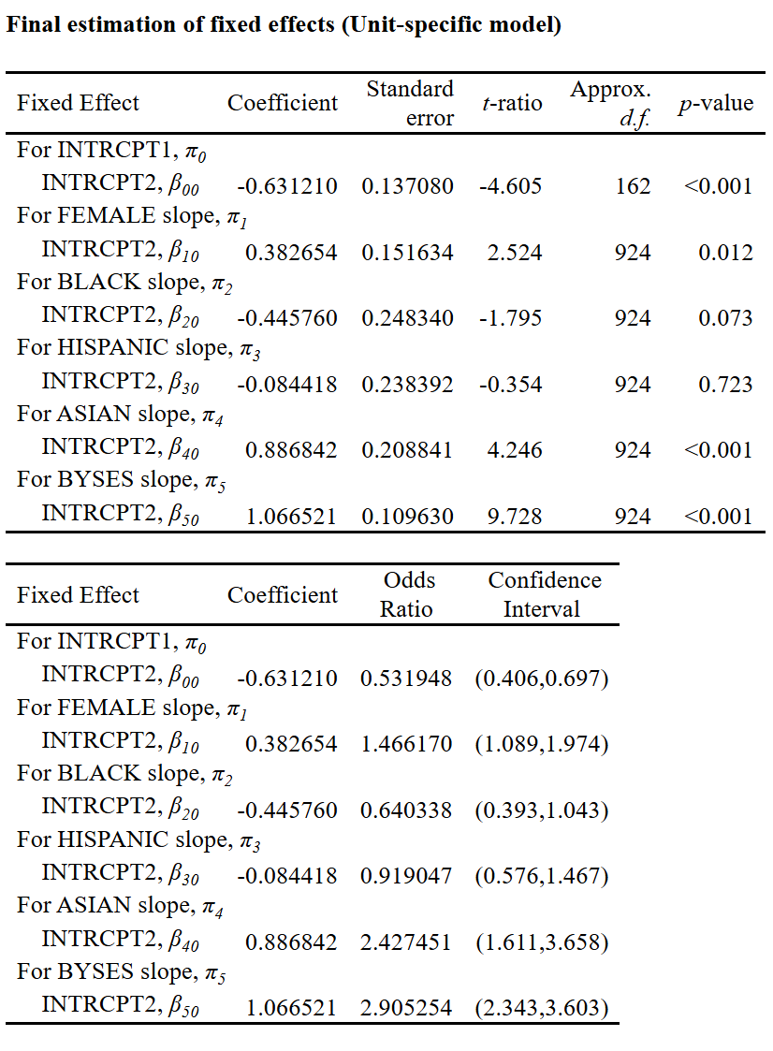
The sampling model here exhibits Y_{ij}, the outcome variable BAGRAD here coded as equal 1 if the person eventually obtained a BA degree and 0 if not, has a binomial distribution. The Y_{ij} is also the number of successes in m_{ij} trials and φ here represents the probability of success on each trial of our test. Thus, our outcome variable follows a Bernoulli distribution. Since our level-sampling model is binomial, the logit link function here is: $η_{ij}=\log\left(\frac{φ_{ij}}{1-φ_{ij}}\right)$, where $η_{ij}$ is the log of the odds of success.
The intercept here, which equals -0.631210, is interpreted as the expected difference in the log-odds of eventual college graduation for a white male student with a zero base year SES. The Female variable predictor represents the expected difference in the log-odds of college graduation associated with the person being female rather than male, while holding all predictors and the random effect constant. The coefficient here is positive, equal to 0.382654 expected log-odds, which means that being a female has more log odds associated with graduation. Conversely, the BLACK coefficient, which equals -0.445760, represents the expected difference in log-odds of repetition between black students baseline and white as a base line in association with the probability of graduating, holding other predictors and the random effect constant. Similarly, the HISPANIC coefficient has an expected difference in the log-odds, which equals to -0.084418, between HISPANIC students and white students, holding other predictors and random effect constant. The ASIAN coefficient has a positive point estimate equals 0.886842, which refers to the expected difference in log-odds between ASIAN students and white students, holding other predictors and the random effect constant. As for the BYSES, it is the expected difference in the log-odds of graduation associated with 1 unit increase in the socio-economic status level predictor, while holding constant the other predictors and the value of the random effect. its positive point estimate shows a positive association and positive increase in log-odds for the person to graduate with each 1-unit change in the base year SES.
Q2)
- Calculate the model-based predicted probability of college graduation for a white male, with a $ⅇ^{η_{ij}}=-0.631210,$: $\frac{ⅇ^{η_{ij}}}{1+ⅇ^{η_{ij}}}$ = 34.7%
- For a white female, eta of the intercept + eta of the female coefficient: 43.82%
- For a Hispanic male: the eta of the intercept + eta of the Hispanic coefficient: 32.84%
- For a Hispanic female: the eta of the intercept + the eta of the Hispanic coefficient + the eta of the female coefficient: 41.75%
Q3)
In comparison between the probability of associated with white females on one hand and Hispanic females on the other, the probability of eventual graduation of college changes from 43.82% to 41.75% respectively. First this shows us that white female students have higher probability than their Hispanic counterparts. The major reason for this is because of the non-linear change due to the logit link functions. The same baseline provides the same starting point, however, when the coefficient or effect of gender is introduced, the marginal effect of it changes depending on the category. So overall, the effect of female is not constant across both groups.

Q4)
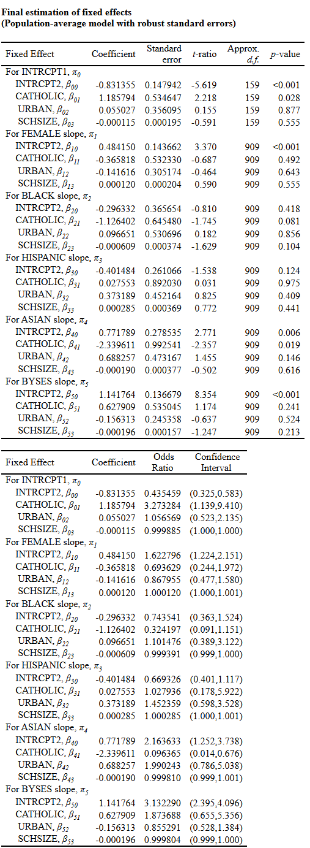
To start with, we argue that the type of school, the geographical location whether the college exists in urban or rural area, and the school size, affect the overall probability of the graduation of the students from the college.
Frist, we notice that when we account for the type of school, the geographical status, and the school size, the overall log-odds change for most of the coefficients. For example, the beta00, which represents the difference in log-odds for college graduation for a white student, in a public school, in rural area, and in an average sized school, the value increased in negativity. The catholic coefficient, beta01, is the expected difference in log-odds between catholic and public schools while holding other variables constant and while averaging across the model, equals to 1.185794 log-odds, and has a p-value of 0.028. this means that the log-odds are higher for catholic schools when it comes to graduation from college. Moreover, this shows a type of school effect or a gap in education. As for the urban coefficient beta 02, the point estimate of 0.055027 is the expected difference in log-odds of college graduation between urban and rural areas, however, it is insignificant since it has a large p-value. The same goes for school size variable that has -0.000115 point-estimate which is interpreted as the expected difference in log-odds of college graduation associated with each 1-unit increase in the size of the school, is insignificant in this case.
As for the Female slope, we noticed that the introduced variables do not hold significance according to their p-values which suggest that we do not have enough evidence to suggest that the type of school, geographical location, and school size, have significant association with the log-odds and probability of Female students to graduate college. Thus, there is no evidence to prove that there is an effect introduced from the variables on the gender effect.
Moreover, the same goes for black students like female students. However, now the coefficient of the black race itself has become insignificant, which means there might be a chance that one or more of our newly introduced variables has a suppression effect. the same goes for Hispanic race variable and its predictors. They all became insignificant. But for the Asian slope, which has a significant intercept equal to 0.771789, reads as the expected difference in log-odds of college graduation for an Asian student in public school, in rural area, and in an average school size. It is noticeable that the point estimate decreased slightly from the unconditional model. It is worth noting that the coefficient of Catholic here is negative, which means the estimated difference in log-odds between catholic schools and public schools for Asian students is in negative.
The base year SES intercept, BYSES, is interpreted as the estimated difference in log-odds of college graduation associated with each one-unit change in BYSES for a student in public school, rural area, average school size. It is equal to 1.141764 log-odds, and has a significant p-value. But again, the newly introduced predictors are still insignificant, suggesting the absence of clear effect, while interacting with base year SES, on the college graduation.
So overall, the effect in attending a catholic school, in light of the other predictors, shows no significant association with college graduation, except for interacting with white and Asian students. The odds ratio for the catholic variable for white students equals to 3.273284, which means that for the college student received prior education in catholic schools, there is a likelihood of occurrence of college graduation of 3.273284. thus, there is a positive association here for white male students with a base year SES equal to 0. The same goes for Asian students being functioned by having educated in a catholic school. The odds ratio here is 0.096365. and since the point-estimate is in negative, then we can notice that there might be a more likelihood of more negative increases for Asian students in catholic schools.

